ST. XAVIER’S COLLEGE

**Maitighar,Kathmandu**

**(Affiliated to Tribhuvan University)**



**Database Management System**

**Lab Assignment #7**

**Submitted By**

Arun Sanjel

B.Sc. CSIT

Year II/IV Semester

013BSCIT010

**Submitted To**

Er. Sanjay Kumar Yadav

Lecturer,

Department of Computer Science

St. Xavier’s College

Maitighar, Kathmandu

**Submitted On**

September 27, 2015

Find the eno, ename of the employee whose salary is greater than 4000  
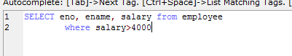

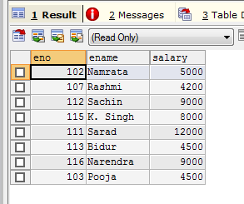

1. Find the eno, ename salary of the employee whose salary is greater than 5000 and job status is professor.

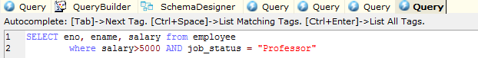

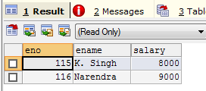

1. Find the eno ename salary of the employee whose dept no 20 or job status research fellow

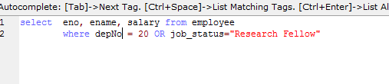

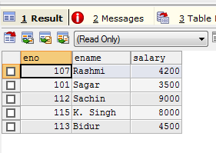

1. Find the eno ename age and salary from the employees where the age is between 24 and 28  
   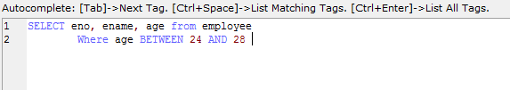

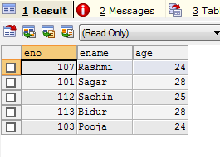

1. Find eno,ename whose starting letter is SA.  
   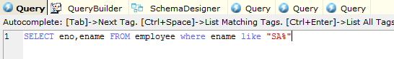

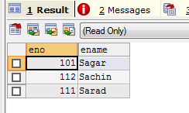

Additional of String operation

Contains RA anywhere in string

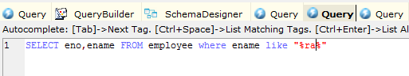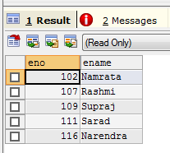

Ends with A

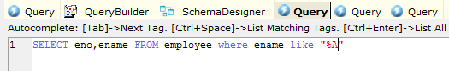

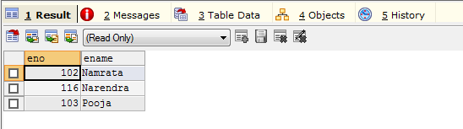

1. List all employee names with their project names.

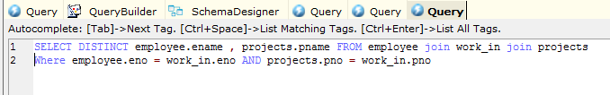

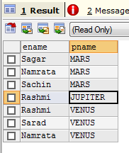

1. List name of all employee and their salary who are working in project MARS or VENUS.
2. List name of All employee and their salary who are working in project Earth and Venus
3. List name and address of all employee who works in department which Is located in Pokhara